Assembly Bill 481 (AB 481)


Prepared by:

UC Merced Police Department

UC POLICE DEPARTMENT ANNUAL REPORT 2026 OF MILITARY EQUIPMENT

University of California Police Department Policy “Military Equipment” requires an annual report to be submitted to the Regents on an annual basis and posted on the police department website for as long as the equipment is in use.

Annual Report
Upon approval of a military equipment policy, the Chief of Police or the authorized designee should submit a military equipment report to the governing body of each type of military equipment approved within one year of approval and annually thereafter for as long as the military equipment is available for use (Government Code § 7072).
The Chief of Police or the authorized designee should also make each annual military equipment report publicly available on the Department website for as long as the military equipment is available for use. The report shall include all information required for the preceding calendar year for each type of military equipment in the Department inventory (Government Code § 7072).
The annual military equipment report shall, at a minimum, include the following information for the immediately preceding calendar year for each type of military equipment:
- A summary of how the military equipment was used and the purpose of its use.
- A summary of any complaints or concerns received concerning military equipment.
- The results of any internal audits, any information about violations of the military equipment use policy, and any actions taken in response.
- The total annual cost of each type of military equipment, including acquisition, personnel training, transportation, maintenance, storage, upgrade, and other ongoing costs, and from what source funds will be provided for the military equipment in the calendar year following submission of the annual military equipment report.
- The quantity possessed for each type of military equipment.

- If the law enforcement agency intends to acquire additional military equipment in the next year, the quantity sought for each type of military equipment.

How Used and Purpose of Use
  - UC Merced PD (UCM) used patrol rifles, 40mm Launchers and training ammunition that were used by officers qualified in their use during range training and qualification. No other military equipment has been used.

Complaints or Concerns

- UCM Police Department received no complaints or concerns during the fiscal year regarding the purchase or use of military equipment or the military equipment policy.

Internal Audits

- UCM conducted audits of their military equipment and there were no violations of the policy found.

Total Costs and Funding Source – Fiscal Year 2025-2026

UCM purchased the following items with an approximate cost of $3,610

(250bx) Federal American Eagle .223rem 62gr FMJ 20rd bx.

This equipment has been purchased and delivered.

Quantity

See below for quantities and new requests

Request for New Military Equipment
Request For Category 1 - Unmanned, Remotely Piloted, Powered Aerial Or Ground Vehicles—The Use Of Drones By University Of California Police Departments
UCM – N/A

Request For Category 10 – Specialized firearms and ammunition of less than .50 caliber, including assault weapons or greater, excluding standard-issue shotguns and standard- issue shotgun ammunition
Under the current law enacted by AB481 (Government Code Section 7070(c)(10)), law enforcement agencies are required to include “Specialized firearms and ammunition of less than .50 caliber, including assault weapons as defined in Sections 30510 and 30515 of the Penal Code, with the exception of standard issue service weapons and ammunition of less than .50 caliber that are issued to officers, agents, or employees of a law enforcement agency or a state agency.”

Assembly Bill 1486 (AB1486) is moving through the legislative process. One of the proposed changes is to GC 7070(c)(10). The proposed change would require law enforcement agencies to include in their military equipment policies specialized firearms and ammunition of less than .50 caliber, including assault weapons as defined in Sections 30510 and 30515 of the Penal Code, with the exception of standard issue service weapons and ammunition of less than .50 caliber that are issued to officers, agents, or employees of a law enforcement agency or a state agency.

As used in this paragraph, a “standard issue service weapon” means a firearm, other than an assault weapon defined in Sections 30510 and 30515 of the Penal Code, that is of the type normally issued to, carried, or transported by a peace officer in the course of routine patrol activities.

This change requires law enforcement agencies to add their patrol rifles and ammunition to the list of military equipment, even if they are considered a “standard issue service weapon.”
UCPD is identifying to the Regents and including in their military equipment policy its patrol rifles and ammunition.

RIFLES

Type: Colt M4LE 6920
Quantity: 15 – UCM
Cost: Approximately $1,100 each (Annual maintenance is estimated to be $100)
Lifespan: 20 years.
Manufacturer Description: This specially designed law enforcement weapon system features many of the combat proven advantages of the military Colt M4. With the 4- position buttstock fully retracted, the Colt Law Enforcement Carbine is less than 32in length and weighs only 6.9lbs - ideal for tactical deployment and traditional patrol.
Capability: Rifles outperform handguns providing a higher degree of accuracy over longer distances. The rifle round will also penetrate soft-body armor.
Purpose: The Carbine .223/5.56- is a shoulder-ﬁred, magazine-fed, gas- operated, riﬂe with a long spirally grooved barrel intended to make a bullet spin and thereby have greater accuracy over a long distance with greater ballistic capabilities than a pistol. Modular accessories aiding in the operation and use include an Aimpoint Red Dot sights optic and an Ultra X300 light mounted on each riﬂe.
Use: The riﬂe is a precision weapon used to address a threat, while out in the ﬁeld on patrol, with more accuracy at greater distances than a handgun. These riﬂes are currently deployed in each of the ﬁve patrol vehicles for use in patrol.
Complaints/Concerns: UCMPD did not receive any complaints or concerns in regards to the use of the Colt riﬂe.
Training: All UCMPD oﬃcers are allowed to deploy the riﬂe in the ﬁeld. Prior to deploying a riﬂe, members must complete a POST certiﬁed course in the operation of the riﬂe. Additionally, all members are required to pass a quarterly department range qualiﬁcation course. All oﬃcers zero the rifle with traditional iron sights and the Aimpoint Red Dot sight. All officers qualify with the RDS.
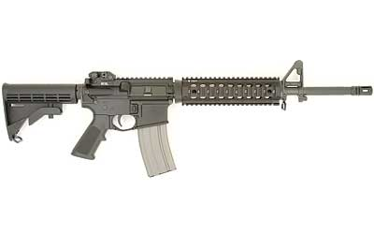

Type: Colt Carbine (LE6940) Patrol Rifle
Quantity: 5 - UCM
Cost: Approximately $1,100 each (Annual maintenance is estimated to be $0 to $100.)
Lifespan: 20 years
Capability: Rifles outperform handguns providing a higher degree of accuracy over longer distances. The rifle round will also penetrate soft-body armor.
Purpose: The Carbine .223/5.56- is a shoulder-ﬁred, magazine-fed, gas- operated, riﬂe with a long spirally grooved barrel intended to make a bullet spin and thereby have greater accuracy over a long distance with greater ballistic capabilities than a pistol. Modular accessories aiding in the operation and use include an Aimpoint Red Dot sights optic and an Ultra X300 light mounted on each riﬂe.
Riﬂe Description: Shoulder-ﬁred ﬁrearms, with riﬂing cut into its barrel, intended to cause projectiles topspin, improving accuracy over a long distance.
Use: The riﬂe is a precision weapon used to address a threat, while out in the ﬁeld on patrol, with more accuracy at greater distances than a handgun. These riﬂes are currently deployed in each of the ﬁve patrol vehicles for use in patrol.
Complaints/Concerns: UCMPD did not receive any complaints or concerns in regards to the use of the Colt riﬂe.
Training: All UCMPD oﬃcers are allowed to deploy the riﬂe in the ﬁeld. Prior to deploying a riﬂe, members must complete a POST certiﬁed course in the operation of the riﬂe. Additionally, all members are required to pass a quarterly department range qualiﬁcation course. All oﬃcers zero the rifle with traditional iron sights and the Aimpoint Red Dot sight. All officers qualify with the RDS.
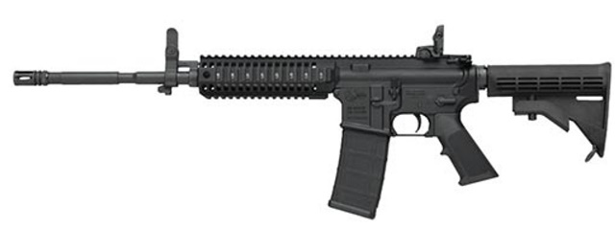

AMMUNITION
Type: 223 Federal American Eagle FMJ/BT
Quantity: 5000 – UCM
Request: 10,000
Cost: 0.72per round / $720 per 1000 rounds
Capability: Ammunition balances expansion and penetration
Manufacturer Description: American Eagle® rifle ammunition offers consistent, accurate, affordable performance for the range. The loads feature quality bullets, reloadable brass cases and dependable primers. Ideal for target practice, accurate and reliable, and consistent primers and brass.
Legal: Officers are required to complete a POST-certified basic rifle course. Officers are authorized by this agency to deploy and use within the course and scope of their duties.
Training: After completing a POST basic rifle course officers qualify 2x a year, one of which is completed in low-light conditions.

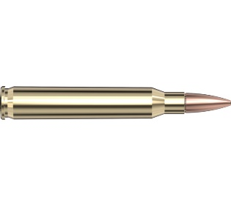

Type: 5.56 Hornady 75gr BTHP
Quantity: 7,600 – UCM
Request: 0
Cost: Approximately $0.98 per round / $980 per 1000 rounds
Capability: Duty ammunition used in the Colt Patrol Rifle. Can penetrate soft body armor. Provides a stable trajectory over longer distances than a handgun.
Manufacturer Description: The T2 bullet profile is specifically designed to optimize function and feeding in M16/M4 variant guns. The cartridge’s propellant technology is custom designed to enhance weapon operation and delivers phenomenal temperature stability. The 75 gr. BTHP T2 bullet is designed to deliver rapid incapacitation upon impact. NOT for use in 223 REM chambered guns.
Powder: Increased powder charge to NATO specifications and pressure peak, Temperature stable with flash retardant Primer: Staked primer pocket, Sealed primer, Small rifle mil-spec primer

Legal: Officers are required to complete a POST-certified basic rifle course. Officers are authorized by this agency to deploy and use within the course and scope of their duties.
Training: After completing a POST rifle course officers qualify a minimum of twice per year, one of which is in low light conditions.
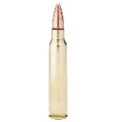
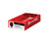

Requests For Category 14 – Kinetic Energy Weapons And Munitions

Quantity: (5) Def-Tec 40mm launchers (Model #1425);
(100) eXact iMpact™ 40mm Sponge Round (Model #6325)
Cost: Approximate Total Cost: $14,500 (Annual maintenance is estimated to be $0 to $100.)
Request: (200) Direct Impact 40mm Reloadable 50-shot Training Kit
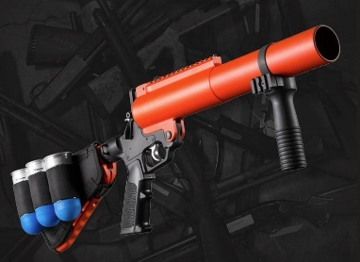
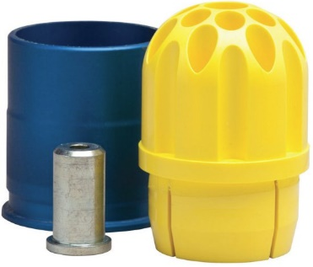
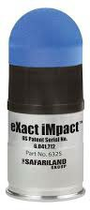

Purpose: 40mm launchers with less-lethal sponge rounds may be deployed to impact subjects who demonstrate assaultive or life-threatening behavior. 40mm launchers utilized with less-lethal sponge rounds may also be used to control an actively resistive subject reasonably believed to possess or have immediate access to a deadly weapon. The main objectives that officers attempt to achieve in using a 40mm sponge round on a subject exhibiting any of the criteria mentioned above are to effect investigative detention or arrest; control a subject who is in lawful custody; prevent an escape; or protect the officer, the subject, or another person from injury or death.
To provide a more cost-effective and realistic training environment the use of 40mm training round is valuable. This reloadable training kit allows officers to practice loading, sighting, trigger pull and range estimate at a fraction of the cost of tactical rounds. With the base sitting on a flat surface, the nose is inserted into to the opening until it clicks. Using the supplied hex key, the screw is loosened and the fired cartridge is removed. A new one is inserted and the screw is tightened. The round is now ready to fire. Total lapse time is under 10 seconds. These rounds are not for use on humans and are training only.
Legal: Use of Force Policy, Crowd and Demonstration Management Policy, and Control Devices and Techniques Policy, First Amendment Assemblies Policy. The department shall only utilize this equipment for official law enforcement purposes and pursuant to State and Federal Law and applicable department policy. Training: Officers that have been trained in the use of the 40mm single launcher undergo thorough classroom and live-fire training in its use. Additionally, officers trained in using the 40mm single launcher must pass annual qualifications to maintain proficiency.
Training: Officers that have been trained in the use of the 40mm single launcher undergo thorough classroom and live-fire training in its use. Additionally, officers trained in using the 40mm single launcher must pass annual qualifications to maintain proficiency.

